Homework - CUNY DATA 624 Sum I

Group 3: Daniel Sullivan, Jeff Parks, Lwin Shwe, Matthew Katz

## HA Exercise 2.1

**Use the help function to explore what the series gold, woolyrnq and gas represent.**

* gold is a time-series dataset of daily morning gold prices in US dollars, from Jan 1, 1985 through Mar 31, 1989.
* woolyrng is a time-series dataset of quarterly production of woolen yarn in Australia, in metric tons (tonnes), from Mar 1965 through Sep 1994.
* gas is a time-series dataset of monthly gas production in Australia, units unknown, from 1956 through 1995.

1. **Use autoplot() to plot each of these in separate plots.**

autoplot(gold) +  
 ggtitle("Daily Morning Gold Prices") +  
 xlab("Days") +  
 ylab("US Dollars")

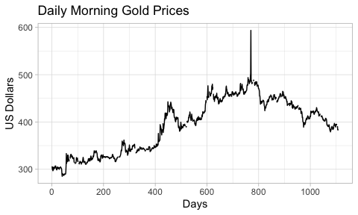

autoplot(woolyrnq) +  
 ggtitle("Quarterly Woollen Yarn Production: Australia") +  
 xlab("Year") +  
 ylab("Metric Tons")

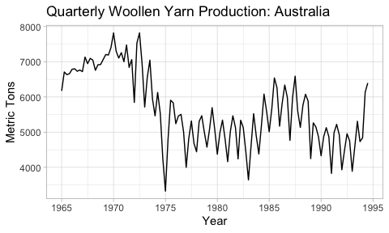

autoplot(gas) +  
 ggtitle("Monthly Gas Production: Australia") +  
 xlab("Years") +  
 ylab("Units")

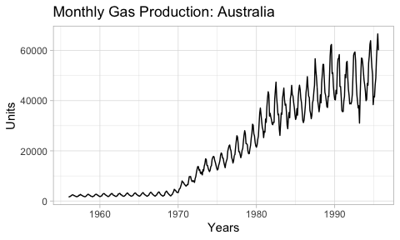

1. **What is the frequency of each series? Hint: apply the frequency() function.**
   * The frequency of gold is 1 (daily)
   * The frequency of woolyrnq is 4 (quarterly)
   * The frequency of gas is 12 (yearly)
2. **Use which.max() to spot the outlier in the gold series. Which observation was it?**
   * The maximum value in the gold series is observation **770** with a value of **593.7**.